School/Dorm Open or Remote Status

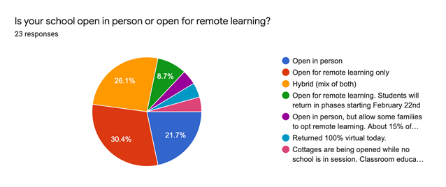

|  |
| --- |
| Open for remote learning only |
| Hybrid (mix of both) |
| Open for remote learning. Students will return in phases starting February 22nd |
| Open for remote learning only |
| Hybrid (mix of both) |
| Open for remote learning only |
| Open in person |
| Open in person |
| Open for remote learning only |
| Returned 100% virtual today. |
| Open for remote learning. Students will return in phases starting February 22nd |
| Cottages are being opened while no school is in session. Classroom education is being done remotely. Local students attend hybrid school (PreK- 1st grade - two classrooms)). |
| Hybrid (mix of both) |
| Hybrid (mix of both) |
|  |