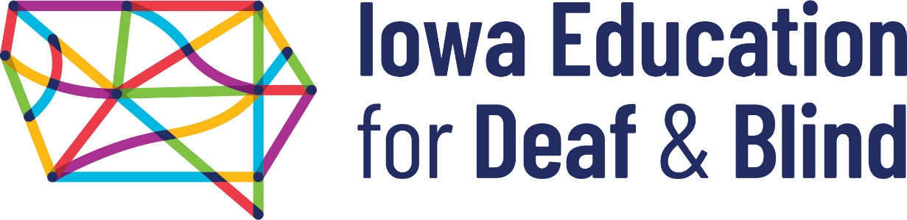

JOB ANNOUNCEMENT
Registered Nurse (evenings)

The Iowa School for the Deaf and Iowa Educational Services for the Blind and Visually Impaired are currently accepting applications for a Registered Nurse. This position is for the evening shift (3:00–11:00 pm) and will work independently performing a myriad of tasks including: student care, medication distribution, updating records, chart auditing, research, and collaboration on school health topics, etc.

GENERAL DESCRIPTION:

Under general supervision of the Head Registered Nurse, provides nursing care to deaf/hard of hearing and blind/visually impaired students within the health center at the Council Bluffs campus location.

CHARACTERISTIC DUTIES AND RESPONSIBILITIES:

- Observes and reports symptoms and conditions of patients, including general physical and mental state.

- Provides emergency medical care and treatment to students and staff.

- Provides medical care and supervision to students who are confined to the Health Center.

- Administers care to acutely ill patients.

- Administers medication and treatments and notes patients’ reactions to same.

- Orders and restocks medication and other medical supplies.

- Coordinates with other departments on campus to ensure continuity of care for each student and to ensure that special needs of students are being met.

- Communicates with parents in order to obtain information relative to each student’s medical history and also to provide follow-up information to parents.

- Utilizes correct nursing procedures and promotes the comfort and safety of all patients.

- Maintains various reports, records, and documentation relating to health care and medical history of students.

- Educates students and staff about health care issues and serves as a resource for students and staff.

- Performs a variety of cleaning and sanitation duties, including changing and laundering of towels, bed linens, students’ clothing, etc.; cleaning and disinfecting medical equipment, tabletops, and countertops; and other related duties.

The tasks listed under the heading of Characteristic Duties and Responsibilities are examples of the variety and general nature of duties performed by employees in positions allocated in the class. The list is descriptive only and should be used for no other purpose. It is not intended that any position include every duty listed nor is it intended that related duties cannot be required.

KNOWLEDGES, SKILLS, AND ABILITIES:

- Knowledge of professional nursing theory and practice.

- Knowledge of current medications, their actions and uses.

- Knowledge of quality standards, procedures and protocols.

- Ability to communicate effectively with staff, students, and parents.

- Ability to follow oral and written instructions.

- Ability to collect information objectively and record information accurately.

- Ability to organize and prioritize multiple tasks.

MINIMUM ELIGIBILITY REQUIREMENTS:

Graduation from an accredited school of nursing. Current registration in the state of Iowa or a compact state. One year of previous nursing experience in a pediatric setting. Knowledge of the special needs of medically fragile children, children with multiple disabilities, and children with learning and behavioral disorders is preferred. The ability to reach the level of sign language proficiency designated for the within the time frame established by the Sign Language Communication Policy.

Good knowledge of general nursing theory and practice. Ability to analyze and solve nursing problems and adapt techniques as necessary in the care of specific patients. Alert and skillful in observing overt and covert signs and symptoms and in initiating appropriate treatment in medical emergencies. Ability to detect changes in patients’ conditions. Ability to work well with students, parents, physicians, supervisors, and other staff members.

SALARY: $23-$35/hour; Full benefits.

WORK SCHEDULE: school year position. Sunday – Thursday, 3:00 pm. – 11:00 pm

TO APPLY:

Apply by downloading an application from ISD’s website www.iowaschoolforthedeaf.org and mailing to IEDB, Human Resources, 3501 Harry Langdon Blvd, Council Bluffs, IA 51503; or emailing it to human.resources@iaedb.org, or by coming to main administration building and turning in an application at the front desk. Or phone 712-366-0571 and request to have an application mailed to you. Be sure to indicate the position for which you are applying on the front page.

The Iowa School for the Deaf/Iowa Educational Services for the Blind and Visually Impaired
is an Affirmative Action and Equal Opportunity Employer.
A Board of Regents, State of Iowa School

