R.E.A.C.H.
Rewarding, Empowering And CHallenging
Program Handbook

High School Dorm Behavior Program
Louisiana School for the Deaf

2020 – 2021

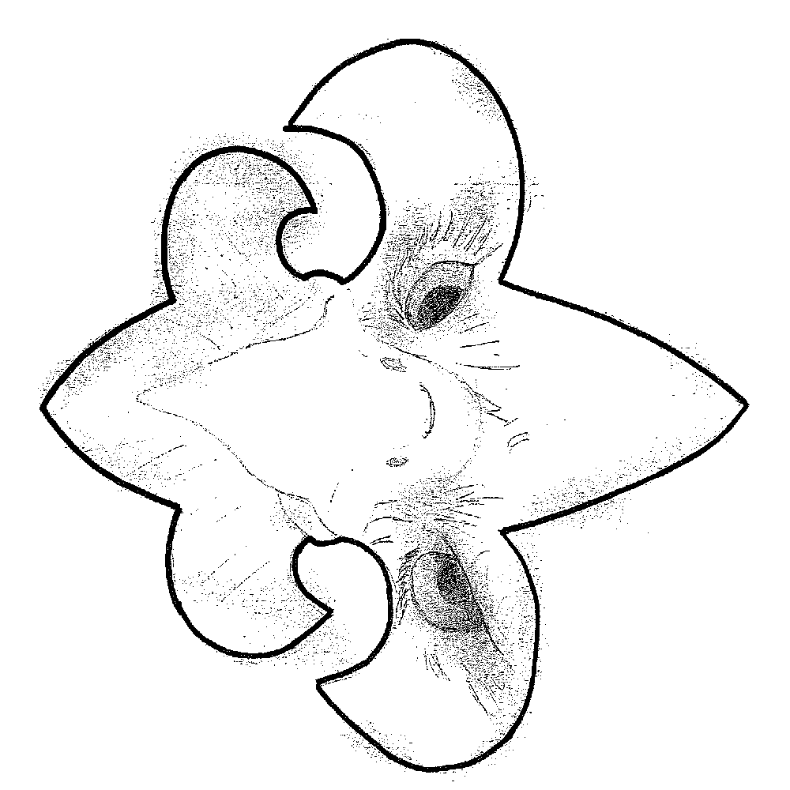

THE R.E.A.C.H. PROGRAM

OVERVIEW
Welcome to the R.E.A.C.H. high school residential program at the Louisiana School for the Deaf. The R.E.A.C. H. (Rewarding, Empowering, And Challenging) is a comprehensive behavior program that incorporates the Positive Behavioral Interventions & Support (PBIS) for developing positive self-regulating behavior among High School residential students at the Louisiana School for the Deaf (LSD). The program is based on the PATHS (Promoting Alternative THinking Strategies) concept in guiding residential students how to effectively express themselves. It is our hope to instill in residential students a functional process that leads to an empowering sense of self-responsibility. Through the R.E.A.C.H. program, residents will learn to:
- Develop skills to recognize how one’s own behavior affects others,
- Understand and use logical reasoning and problem-solving vocabulary,
- Gain knowledge of and skill in the steps of social-solving, leading to the prevention and/or resolution of problems and conflicts in daily life,
- Become self-advocates and exhibit leadership qualities,
- Earn privileges and develop responsibility by demonstrating control over and ownership of their behavior by following established dorm/school expectations and policies.

The R.E.A.C.H. program:
- Rewards and reinforces students for positive behavior.
- Empowers residents in ways to take responsibility for their own behavior.
And
- Challenges High School students to become self-advocates and exhibit leadership qualities by building on each student’s dignity, respect, and self-esteem.

PBIS
LSD uses a behavior instruction system called Positive Behavior Interventions and Supports (PBIS). This system has been established in research as an effective method for establishing cultural and behavioral support needed for all students to achieve social and academic success. The expectations for the dorm life are divided into three components: Obedience, Independence and Courteousness (OIC). The OIC expectations will be posted in each dorm with pictures and expectations.
Restorative Practices/Social and Emotional Learning:
Restorative Practices is a whole child approach designed to address student behavior by identifying and fulfilling needs and replacing punitive disciplinary practices with strategies, which build community and resolve interpersonal conflict.
Social and Emotional Learning (SEL) is the overall process by which students:

- Understand and manage feelings
- Relate appropriately with others
- Deal with conflict and other life challenges in a positive manner
- Make good decisions
- Transition from a school environment to the real world

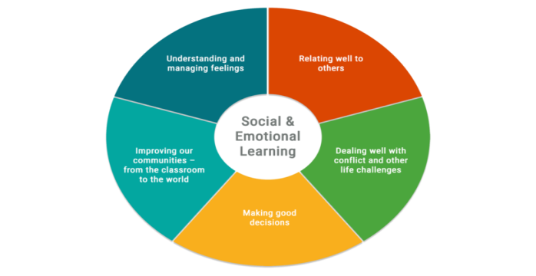

MOVING UP and DOWN LEVELS:
New residential students enrolled in the REACH program will start on Level 2. They will remain on Level 2 until he/she earns 20 checks. After he/she earns 20 checks, he/she will move up to Level 1.
When he/she earns 2 X, he/she will be dropped down to Level 2 during the monthly period.

If a student earns an X, he/she will be required to turn in his/her phone one hour early.

Level Status | Moving Up | Positive Consequences | Moving Down  (within monthly period)
CLAWS |  | Refer to Privilege Chart | 1 X  Any Minor or Major Infraction
Level 1 | 9 Weeks consecutively | Refer to Privilege Chart | 2 X
Level 2 | 20 | Refer to Privilege Chart | 3 X
Level 3 | 10 | Refer to Privilege Chart

Moving Up/Down Levels

CLAWS
1 X

9 weeks
consecutively
Level 1
2 X

10 Checks
Level 3

20 Checks

Level 2
3 X

TAKING PICTURES
Residential students are not allowed to take pictures of staff and/or students without knowledge and permission.

REACH LEVEL PRIVILEGES
Chart
Privileges | C  L  A  W  S |  | L  E  V  E  L  1 |  | L  E  V  E  L  2 |  | L  E  V  E  L  3
RECREATION/SPORTS
** Participate in social time listed on  Activity Schedule | ✔ |  | ✔ |  |  |  |  *
** Participate in school sports (athlete) | ✔ |  | ✔ |  | ✔ |  | ✔
** Participate in school sports (fans) | ✔ |  | ✔ |  |  |  |  *
** Participate in Center activities | ✔ |  | ✔ |  |  |  |  *
** Participate in PEC activities | ✔ |  | ✔ |  |  |  |  *
** Participate on campus dorm activities | ✔ |  | ✔ |  | ✔ |  |  *
** Participate off campus dorm activities | ✔ |  | ✔ |  |  |  |  *
** Participate Mall trip | ✔ |  |  |  |  |  |  *
** Visit opposite sex in lounge (after 9 pm) | ✔ |  |  |  |  |  |  *
MEAL/SNACKS
Earn PBIS snack |  | ✔ |  | ✔ |  | X  Tuesdays only |  | 
** Can order foods before 8:00 pm |  | ✔ |  | ✔ |  | ✔  7:30 pm |  | 
ELECTRONIC DEVICES
Can use electronic devices |  | ✔ |  | ✔ |  | ✔ |  |   Homework  only
Turn in electronic devices |  |  |  | 30 minutes before bedtime |  | 1 hour before bedtime |  | 
Keep electronic devices in bedroom |  | ✔ |  | X |  | X |  | 
Use FaceTime or other video chats in the suite |  | ✔   |  | ✔ |  | X |  | 
VIDEOPHONE
Can use phone and videophone |  | ✔ |  | ✔ |  | ✔ |  |   Parents only

- Level 3 will be restricted to their suite at all times except for educational workshops and Student Health Center

CLAWS

In order for a residential student to earn CLAWS Level, he/she must stay on Level 1 for 9 consecutive weeks. He/she will demonstrate the ability to follow the dormitory expectations, be able to go to bed and wake up on time, be able to maintain grades and do homework independently, be able to function in their daily routine with minimal staff supervision and prompts, be able to show appropriate behavior in the cafeteria during breakfast and supper.

Any primary and secondary behavior infractions and failing grades will result in immediate level demotion from the CLAWS Level according to the REACH program. When he/she drops from CLAWS, he/she will have to stay on Level 1 for 9 consecutive weeks before applying for the CLAWS Level again.

PRIVILEGES
Independent study hour
Go to bed without prompts
Will arrive in the lounge area on time before going to breakfast
Turn in cell phones/pagers without being told and on time
Able to stay up until midnight – remain in your suite at 11:30 pm
May use the laundry room before 11:00 pm
No time limit for computer and VP (if waiting list, 20 minutes)
May use computer and VP downstairs
** Able to visit the opposite sex in the lounge area
** Able to participate the mall trip (Stay on CLAWS for 2 weeks)
** Able to sign up for the shuttle
EXPECTATIONS
Required participation during workshops and meetings
Will keep your areas (tables, bedroom, living room) clean
Show respect to any staff and disagree in a respectful manner
Seniors
Will be responsible for paying monthly rent
REQUIRED to perform senior apartment duties

Louisiana School for the Deaf
High School Dorm
CLAWS Level Application

NAME: ______________________________ DATE: ________________

GRADE: ________

Please tell us why you should be on the CLAWS level?__________________________ _______________________________________________________________________________________________________________________________________________________________________________________

Overnight Staff Name:___________________________________________________
€ I agree € I disagree

Comments:__________________________________________________________________________________________________________________

Evening Staff Name: ____________________________________________

Comments:____________________________________________________________
_____________________________________________________________________

Student Development Specialist (SDS)Name: _________________________________
€ I agree € I disagree

Comments:__________________________________________________________________________________________________________________

Overnight RTL Name: _________________________________________________
€ I agree € I disagree

Comments: _______________________________________________________

Final Decision: € Approved € Not approved Date: ______________
Residential Team Leader: ______________

UPDATED 5/26/2 LOUISIANA SCHOOL FOR THE DEAF

HIGH SCHOOL DORMITORY

R.E.A.C.H. PROGRAM
STUDENT-PARENT CONTRACT

BEHAVIOR PROGRAM:

Parent/Guardian: (please initial)

____ I HAVE COMPLETELY READ AND FULLY UNDERSTAND THE REACH PROGRAM AND AGREE TO FOLLOW THE GUIDELINES SET FORTH.

WORKSHOPS and ACTIVITIES:

____ I UNDERSTAND THAT R.E.A.C.H. WORKSHOPS AND EDUCATIONAL ACTIVITIES REQUIRE STUDENT’S PARTICIPATION. I FULLY AGREE THAT MY CHILD WILL ATTEND THESE WORKSHOPS AND ACTIVITIES SPONSORED BY THE R.E.A.C.H. PROGRAM.

YES or NO I give permission for my child to bring their own camera, cell phone,
______ DVD player/movies, game consoles, and other electronics. (LSD will not be responsible for repairs, damage, and/or theft)

----------------------------------------------------------------------------------------------------------------------------------------------------

Students: (please initial)

NOTE: STUDENTS HAVE RECEIVED AN EXPLANATION OF THE REACH PROGRAM THROUGH SIGN LANGUAGE OR PREFERRED COMMUNICATION MODE.

____ I ALSO UNDERSTAND THAT SIGNING THIS AGREEMENT WILL MEAN THAT I WILL SUPPORT THE PRIVILEGES AND CONSEQUENCES OF THE REACH PROGRAM.
----------------------------------------------------------------------------------------------------------------------------------------------------

SIGNATURES:

STUDENT Date

PARENT/GUARDIAN Date

STUDENT DEVELOPMENT SPECIALIST Date

PLEASE SIGN AND RETURN TO:

Student Development Specialist
High School Dorm
Louisiana School for the Deaf
P.O. Box 3074
Baton Rouge, LA 70821-3074
FAX (225) 757-3428

