1st Choice

Elementary Dorm Behavior Program
LA School for the Deaf
2020-2021

Gold War Eagle

Silver War Eagle

Bronze War Eagle

PBIS

LSD uses a behavior instruction system called Positive Behavior Interventions and Supports (PBIS). This system has been established in research as an effective method for establishing cultural and behavioral support needed for all students to achieve social and academic success.
The 1st Choice is a comprehensive behavior program that incorporates the Positive Behavior Interventions & Support (PBIS) for developing positive self-regulating behavior among Elementary residential students. Through this program, students will learn to:
- Develop skills to recognize how one’s own behavior affects others
- Understand and use logical reasoning and problem-solving vocabulary
- Gain knowledge of and skills in the steps of social solving, leading to the prevention and/or resolution of problems and conflicts in daily life.
- Become self-advocates and exhibit leadership qualities
- Earn privileges and develop responsibility by demonstrating control over and ownership of their behavior by following established dorm expectations and policies.

The expectations for dorm life are divided in three components: Obedience, Independence and Courteous (OIC). The OIC expectations will be posted in each dorm with pictures and expectations.
Restorative Practices/Social and Emotional Learning:
Restorative Practices is a whole child approach designed to address student behavior by identifying and fulfilling needs and replacing punitive disciplinary practices with strategies, which build community and resolve interpersonal conflict.
Social and Emotional Learning (SEL) is the overall process by which students:
- Understand and manage feelings
- Relate appropriately with others
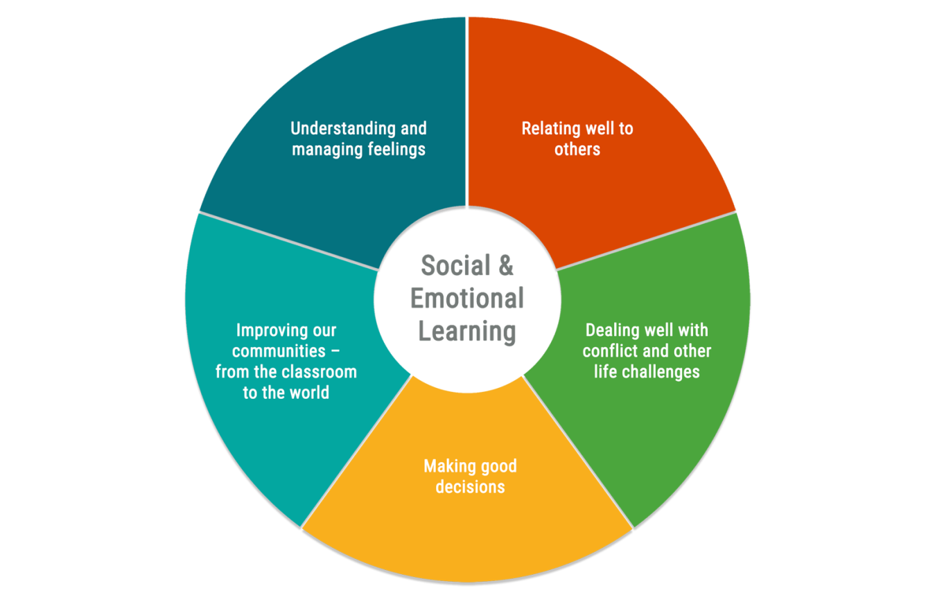
- Deal with conflict and other life challenges in a positive manner
- Make good decisions
- Transition from a school environment to the real world

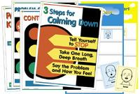

The elementary dorm program uses the Promoting Alternative Thinking Strategies (PATHS) curriculum, which aims to promote emotional and social competencies while reducing aggression and behavior problems in students by increasing their ability to develop effective alternative solutions. Our goal is to instill in residential students a functional process that leads to an empowering sense of self-responsibility.
Elementary Behavior Program
(Pre-K-5th grade)

1st Choice is based on the concept of immediate reinforcement and consequences, which enables the easily frustrated child to begin to learn the ability to manage and control their frustration and thereby enhance their self-esteem. This program will also teach students responsibility and time management.

For Pre-K-2nd grade, the purpose of this behavior program is for young students to experience immediate rewards/consequences and for the student to exhibit behavior that is positive and accepting of such rewards/consequences. Short term and immediate reward/consequences should enable the student to experience and understand that he/she is in control of the reward/consequences dependent on their behavior. The student will understand that positive behavior means full participation in the activity of the day.

This program for 3rd-5th graders utilizes three Levels: Gold, Silver and Bronze. This system is divided into recurring two week periods throughout the school year. All new students will begin the behavior program on Silver Level. Students will earn a check when the appropriate behaviors are shown each day. While on Silver, if a student acquires 5 X’s, he or she will be moved down to Bronze level. From Bronze, 3√’s are required to advance to Silver Level. From Silver, 5√ ’s are required to advance to Gold Level. While on Gold, if a student acquires 3 X’s, he or she will move down to Silver. Silver Level guarantees normal privileges, such as normal bed time, use of electronics etc... without restriction.

If a student achieves Gold Level, his/her rewards will increase. If a student obtains Bronze, it will result in a decrease of privileges and rewards. Each student’s progress will be posted in the dormitory where students can see their progress, including: how many checks they currently have, how many checks they need to move up to the next level and how many X’s they currently have.

During each two week period, students will have the opportunity to earn PBIS tickets based on positive behavior and a positive attitude. These tickets may be used to ‘purchase’ rewards in order to celebrate and encourage future positive behavior. Students who continue to display positive behavior and earn daily behavior rewards will be eligible for the nine weeks good behavior trip. The Student Development Specialist will keep track of each student’s ticket amounts by tallying the tickets daily on a special chart in the Behavior Log. Each student will have their own ziploc bag to keep their tickets in.

Privilege Chart
Privileges  3th, 4th, 5th grades | GOLD | 3Xs ► | SILVER | 5Xs ► | BRONZE
3th, 4th, 5th grades |  | ◄5✔s |  | ◄3✔s
RECREATION
Participate in social time/dorm activities | ✔ |  | ✔ |  | 🞬
Participate in PEC activities | ✔ |  | ✔ |  | 🞬
Can go off campus | ✔ |  | ✔ |  | 🞬
ELECTRONICS
Can use computer and IPAD | ✔ |  | ✔ |  | Homework Only
BED TIME
4th & 5th graders | 9:15 pm | IF X  9:00 pm | 9:00 pm | IF X  8:45 pm | 8:45pm | IF X  8:30 pm
3rd graders | 9:00 pm | IF X  8:45 pm | 8:45 pm | IF X  8:30 pm | 8:30 pm | IF X  8:15 pm
Turn in electronics 45 minutes before bedtime to wind down before bed. | 4th/5th-8:30 pm  3rd - 8:15 pm |  | 4th/5th-8:15 pm  3rd - 8:00 pm |  | X
Revised 6/24/20

Moving Up/Down Levels

Gold
3X

5 ✓

Silver

5 X

3 ✓
BRONZE

LOUISIANA SCHOOL FOR THE DEAF
Elementary Dormitory
1st Choice Behavior PROGRAM
STUDENT-PARENT CONTRACT

BEHAVIOR PROGRAM:
Student - Please initial

____ I HAVE COMPLETELY READ AND FULLY UNDERSTAND THE 1ST CHOICE PROGRAM AND AGREE TO FOLLOW THE GUIDELINES SET FORTH.

NOTE: STUDENTS HAVE RECEIVED AN EXPLANATION OF THE 1st CHOICE PROGRAM THROUGH SIGN LANGUAGE OR PREFERRED COMMUNICATION MODE.

____ I ALSO UNDERSTAND THAT SIGNING THIS AGREEMENT WILL MEAN THAT I WILL SUPPORT THE PRIVILEGES AND CONSEQUENCES OF THE 1st CHOICE PROGRAM.

WORKSHOPS and ACTIVITIES:
Parent/Guardian - Please initial

____ I UNDERSTAND THAT 1st CHOICE PROGRAM WORKSHOPS AND EDUCATIONAL ACTIVITIES REQUIRE STUDENT’S PARTICIPATION. I FULLY AGREE THAT MY CHILD WILL ATTEND THESE WORKSHOPS AND ACTIVITIES SPONSORED BY THE 1ST CHOICE PROGRAM.

SIGNATURES:

STUDENT Date

PARENT/GUARDIAN Date

STUDENT DEVELOPMENT SPECIALIST Date

PLEASE SIGN AND RETURN TO:

Student Development Specialist
Elementary Dorm
Louisiana School for the Deaf
2888 Brightside Drive
Baton Rouge, LA 70820

UPDATED 6/24/20

