Anti-bullying program

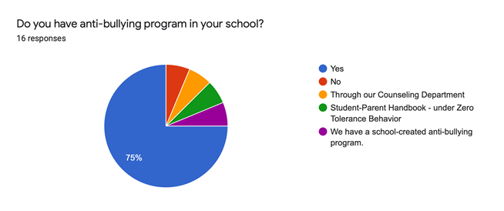

|  |
| --- |
| **Name of your anti bullying program** |
| Olewus Bully Prevention Program |
| Customized PowerPoint based on different sources |
| SOAR (safety, open-minded, accountability, respect) |
|  |
|  |
| Second Step (elementary), Anti-bullying assemblies and awareness videos |
| We have 3 counselors and 2 support person. Not sure of the name. |
| SOAR (safety, open-minded, accountability, respect) |
| MTSS- RTI2B |
| We follow the curriculum/recommendations from National Bullying Prevention Center |
| Bullying intervention |
| Say No to Hate |
| SOAR (PBIS Behavioral Expectations) |
| SOAR (safety, open-minded, accountability, respect) |
| Social / Emotional learning |