Behavior Program Manual for Dorm

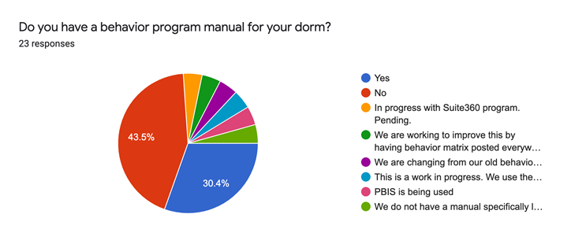

|  |
| --- |
| No |
| No |
| In progress with Suite360 program. Pending. |
| Yes |
| We are working to improve this by having behavior matrix posted everywhere. We have CPI and BPIS in place. |
| Yes |
| No |
| Yes |
| No |
| We are changing from our old behavior program to align with our new VTSS plan from VDOE |
| This is a work in progress. We use the MTSS approach here along with the Viking Level System. |
| No |
| Yes |
| No |
| Yes |
| PBIS is being used |
| No |
| We do not have a manual specifically labeled behavior program but we follow MANDT which governs how we manage behavior. Our parent-student handbook has a section on how we manage behavior. |
| Yes |
| No |
| Yes |
| No |
| No |